Getting your MCIS Account updated for 2022-23
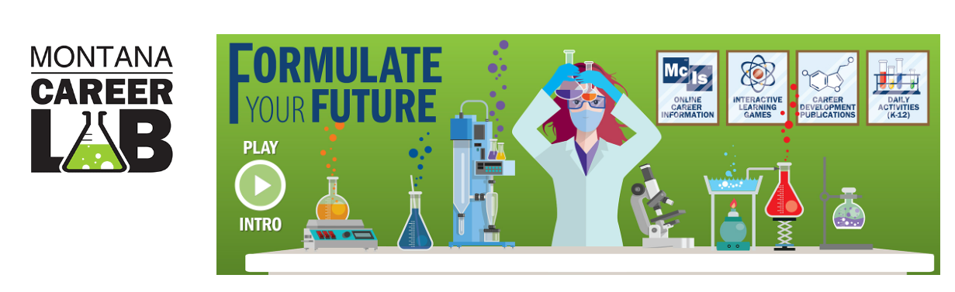
- Login into the Career lab web page it should look like the photo above.
  - https://lmi.mt.gov/career/ OR careers.mt.gov
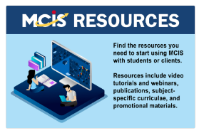
- Scroll down to MCIS RESOURCES
- Click on the MCIS RESOURCES
- Once you have clicked on the MCIS RESOURCES page you
  - Will see MCIS Site Order form below
  - Click on the MCIS Site Order form & complete the form submitting it to us.
