LOGIN TO MCIS Old Version and To MCIS 360

IF YOU DO NOT HAVE A LOGIN FOR THE MCIS OR FORGOT YOUR PASSWORD PLEASE CONTACT ME AT: maryellen.earnhardt@mt.gov DO NOT LOGIN IN WITH THE ZIPCODE. We want to have you login to your school’s account!!

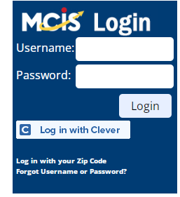
Currently we are in the process of transitioning over to the new version of MCIS which we have named MCIS 360. Our system is set up so that you can toggle back and forth from the old version to the new one. BELOW ARE THE STEPS FOR LOGIN TO MCIS
- Login using : https://lmi.mt.gov/career/ OR Careers.mt.gov
- Type in your username and password.
- If you do not have a login contact me OR you can do the practice site.
- This is only a practice site
  - U: hstraining_admin
  - PW: Hstraining1

When you open your site you will be at the administrative page: Click on Go to CIS360 and it will take you to the new site . To Go to back to the old MCIS click on the down arrow by the name Jane (if its your site your name will be there instead of Jane) and it will take you back to the old MCIS
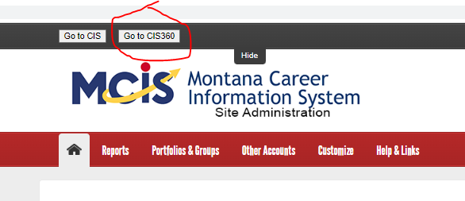
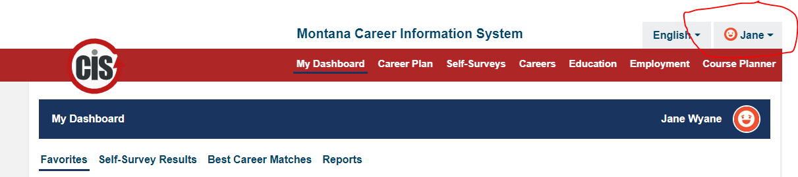

GO TO PAGE 2 FOR STUDENT INFORMATION

STUDENTS:
Follow the steps above for login in:
- Login using : https://lmi.mt.gov/career/ OR Careers.mt.gov
- Type in your username and password.
- If you need help setting up your students with a login, contact me
  - Maryellen.earnhardt@mt.gov

- Once your students have login to mics have them use the drop arrow on the right hand side and click on Go to MCIS 360 drop down menu
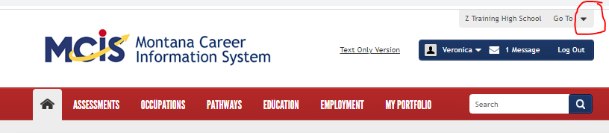

MCIS 360 WILL LOOK LIKE THIS!
- To go back to the old version click on the down arrow and go to MCIS.
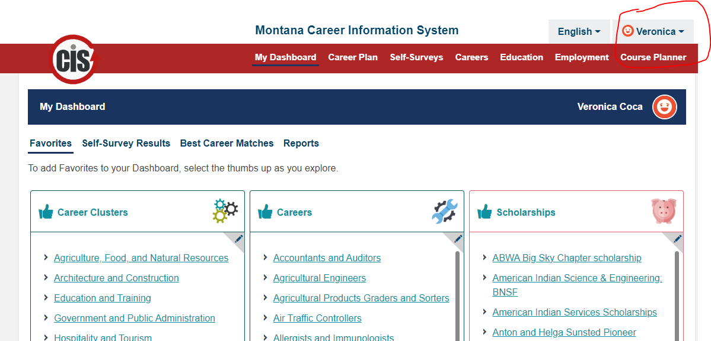
Go to Page 3 for more details on MCIS 360
- Clicking on the red task bar will take you to various section. For this section we will only do the the career plan

Click on the career plan
- Click on the down arrow for the grade needed
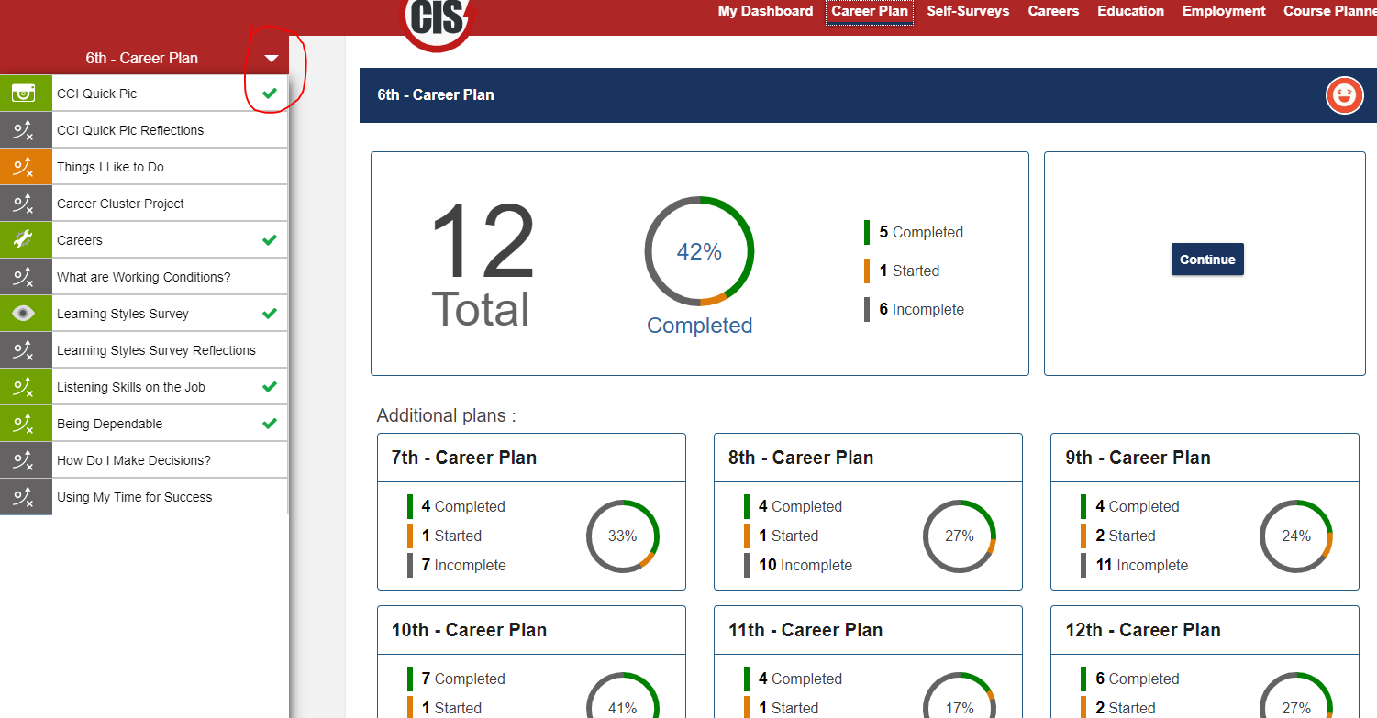

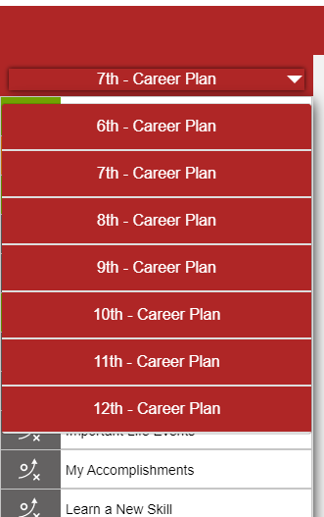
- Click on the items you would like to complete and for the next grade click on that down arrow and click on the grade level you would like to go to next.
- Practice using all the grade task and also the other tabs on the red task bar for
Tutorial videos go to : https://lmi.mt.gov/career/MCISResources

AND PLEASE E-MAIL I am willing to do one on ones once you learn this it is very easy.
Maryellen.earnhardt@mt.gov

- All items will be saved on both systems so there is no need to transfer any work.
- The skills assessment is ONLY on the MCIS NOT the new version
- The resume on MCIS does not have the same formatting as MCIS 360

